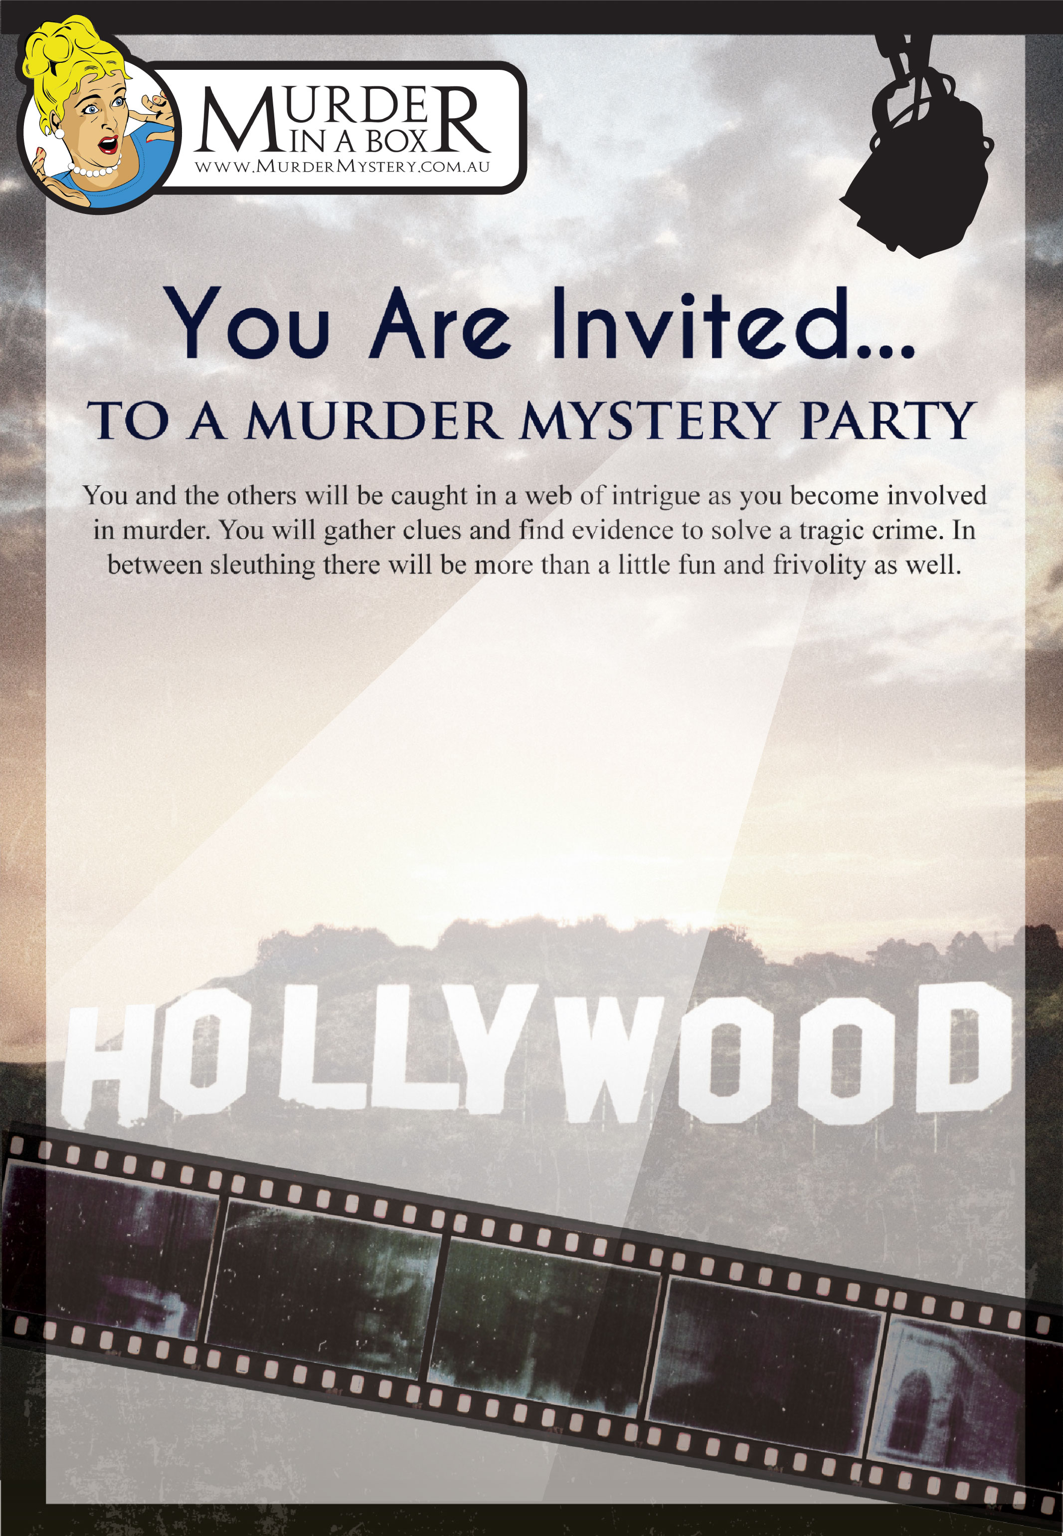

*Dear Name*

*You are invited to attend event*

***Theme and Costume***

*Theme: Hollywood Scandal*

*Costume Ideas: Please come dressed as your favourite Hollywood actor or character or come in your awards night finest.*

***Venue***

*Name: Our house*

*Address:*

***Date and Arrival Time***

*Arrival Time: 7:00 PM*

*Date: 31/10/2025*

***RSVP***

*Date: 31/10/2025*

*Contact:*

*Phone:*

*Email:*

***Notes***

*Please arrive on time so that the party can get under way.*